Student Name | G. Manasa
Student Registration Number | 241U1R3007 | Class &Section: CSE(DS)
Study Level: UG/PG | UG | Year &Term: I & II
Subject Name | Probability & statistics

Name of the Assessment | Reflective Journal -8
Date of Submission | 31/08/2025

Reflective Journal Template
Journal Entry Guidelines | Description
1. Experience (Class Content) | Briefly describe the topics or concepts discussed during the class.
2. Feelings (Emotional Reactions) | Share your emotional reactions and thoughts during the class.  How did you feel while learning this theory?  Did the class evoke specific emotions or questions?
3. Learning (Key Insights) | Reflect on what you learned from the class.  Highlight the key insights or fundamental concepts you gained from the class.
4. Application (Practical Use) | Describe how you plan to apply the theory you've learned in real-life situations or in your academic/career endeavours.  Explain the practical utility of this theory.

Sample Journal Entry

Date | 31-08-2025
Journal Entry Topic | Small samples  Tests Concerning a Single Mean, Tests on Two Means, Chi–square test., F-Test
1. Experience (Class Content) | In this module we learned about small samples if the size of sample is less than 30 then the sample is treated as small samples. And next we discussed about test of significance for small samples and there are some important test for small samples are  - Student ‘t’ test  - F- test  - $x^{2 }$-test  Student t test is defined by the statistic  $$t=\frac{xˉ-μ_{0}}{s/\sqrt{n}}$$  And next we discussed about assumptions for student’s t test and later we learned about student’s test for single mean in that we learned about null hypothesis, alternative hypothesis, level of significance, test statistics after that we learned about T-test for two means it assumed that population variance are equal and unknown.  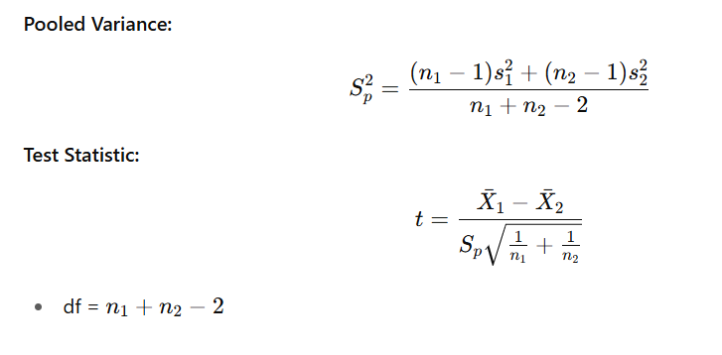  And next F-test or F test for equality of variance  $F=\frac{{s1}^{2}}{{s2}^{2}}$ df1=n1​−1, df2=n2​−1  And next we learned about chi-Square test for goodness of Fit the most powerful test for testing the significant difference between the theory and experiment is chi- square test.  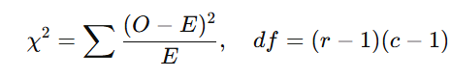  At last we discussed about degrees of freedom the number of independent variance which make up the statistics is known as degree of freedom and it is denoted by χ²
2.Feelings (Emotional Reactions) | In the beginning, I felt nervous because the formulas looked difficult especially with terms like pooled variance, degrees of freedom, and chi-square values. It was hard to remember which test to use in which situation. But when I practiced more examples with the help of my teacher I slowly started feeling confident. I enjoyed seeing how these tests could give answers to real questions, like whether training really improved performance or whether two groups were different. I felt happy and proud whenever my answers matched the values in the statistical tables and gave a clear decision.
3. Learning (Key Insights) | 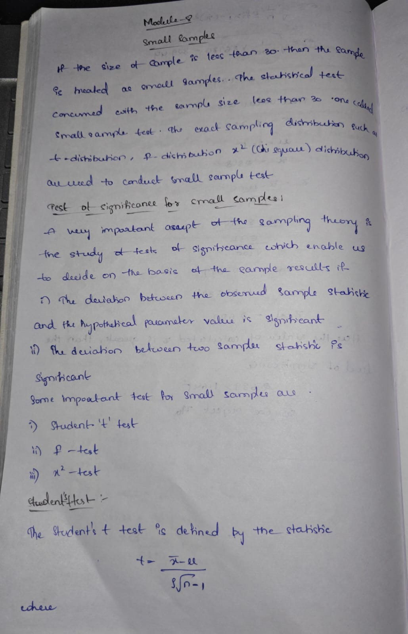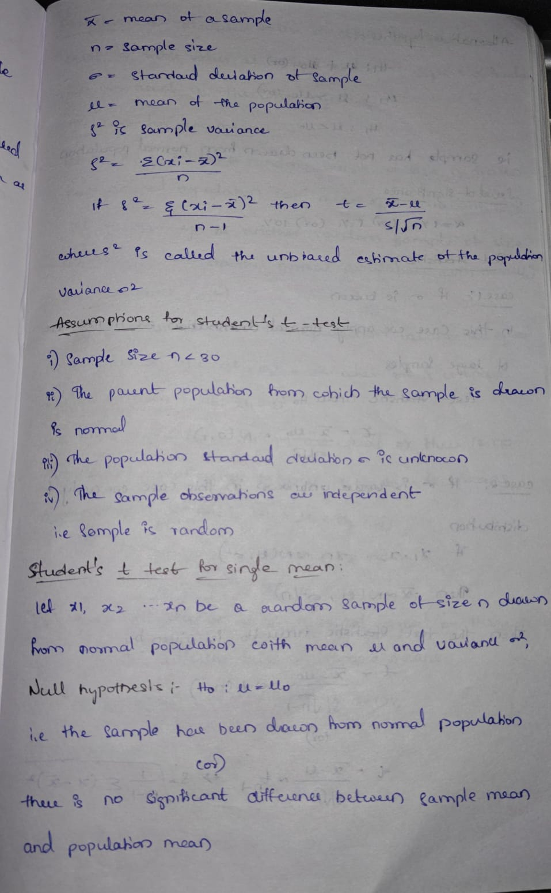  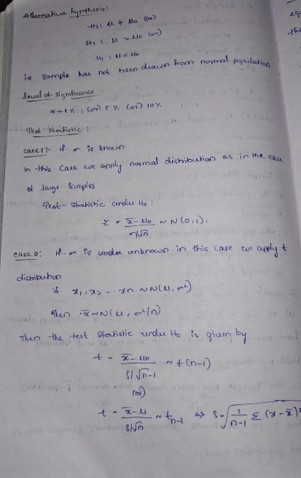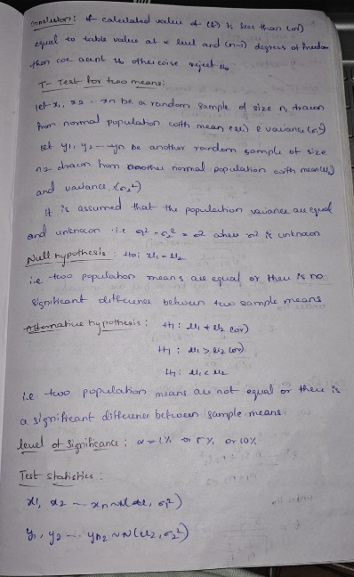  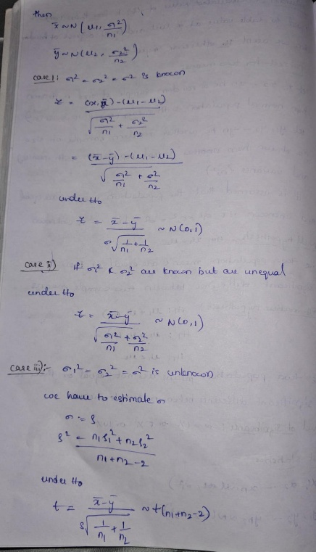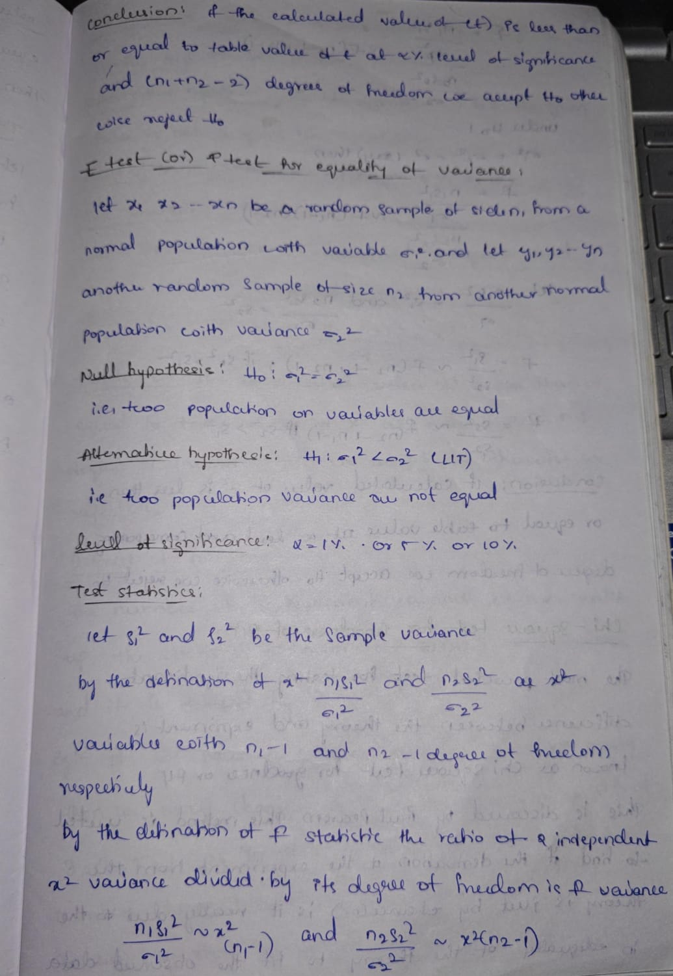  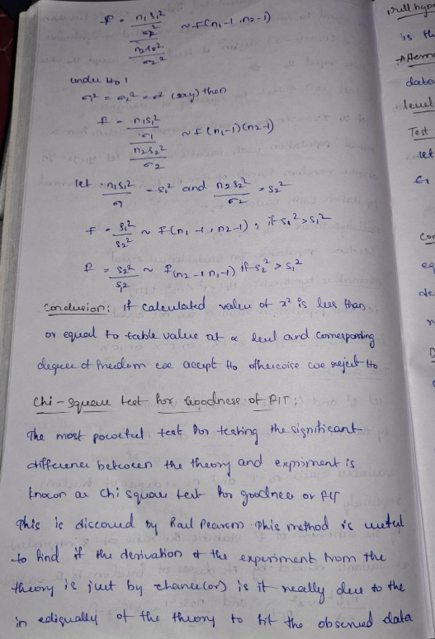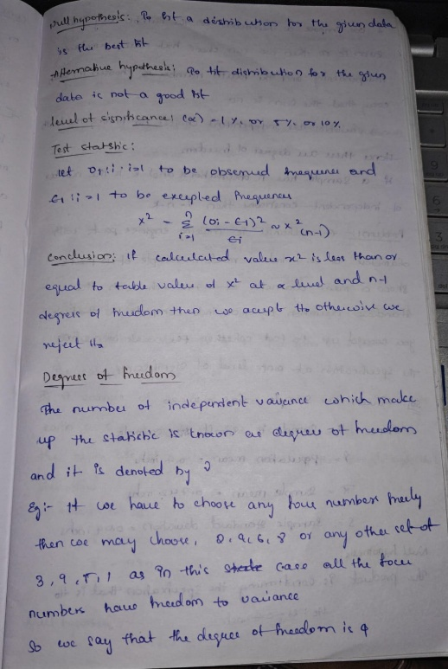  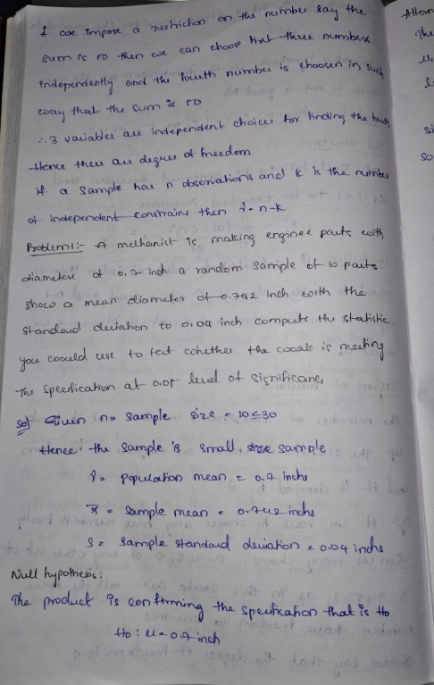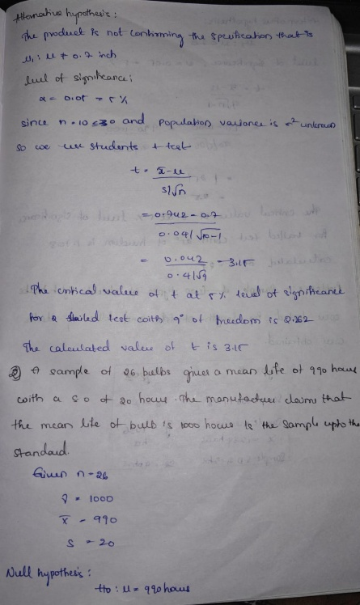  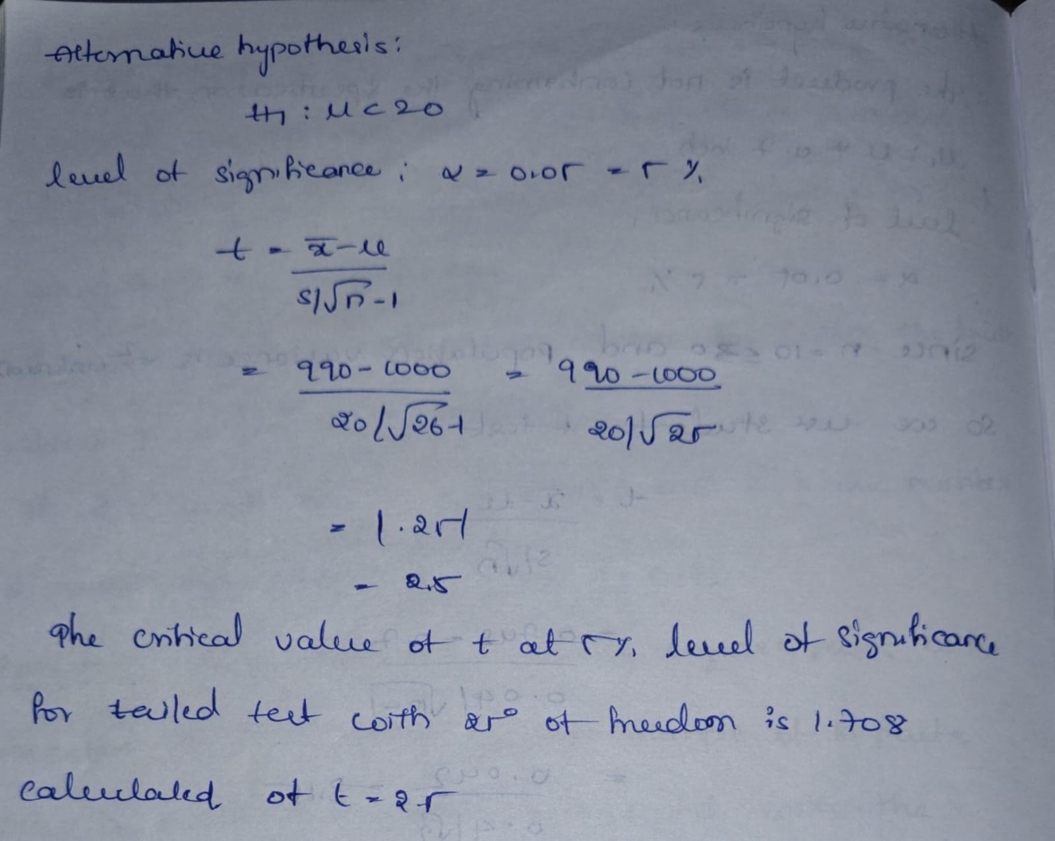
4. Application (Practical Use) | Small Sample Tests (t-Test)  - Test Concerning a Single Mean:  Used when the population standard deviation is unknown, and you have a small sample size (typically n < 30).  Application:  Determining if a small group of students' average test scores significantly differs from the national average.  - Tests on Two Means:  Compares the means of two independent or related small samples when the population standard deviation is unknown.  Application:  Testing if there's a significant difference in the average intelligence scores between a sample of boys and a sample of girls, as shown in the eGyanKosh example.  Chi-Square Test  Applications:  Goodness-of-Fit Test: Checks if an observed frequency distribution of a single categorical variable matches a theoretical or expected distribution.  Example:  Determining if the results of 100 coin flips (observed) match the theoretical expectation of 50 heads and 50 tails for a fair coin.  Test of Independence: Examines whether there is a significant association or relationship between two categorical variables.  Example:  Analyzing if gender (male/female) is independent of a preference for a particular type of movie (action/comedy).  Cryptanalysis: In cryptography, it's used to compare the distribution of plaintext and ciphertext to assess the success of a decryption process.  F-Test  Applications:  Comparing Variances: The primary use is to determine if the variances of two independent populations are equal.  Example:  Before performing a t-test on two independent samples, an F-test can check if the assumption of equal variances (a prerequisite for some t-tests) is met.
Conclusion | At first, I felt statistics was only about solving formulas, but now I see it as a way of thinking and analyzing situations. These tests taught me patience, logic, and accuracy. I also realized that statistics is deeply connected to real life. Whether it is in education, business medical research or manufacturing, these tests help people make decisions with confidence. Even though the sample size may be small the tests ensure that our conclusions are reliable.  As a student I feel more confident now to use these methods whenever I face situations where I have only small sets of data. Instead of feeling helpless I know I can apply these tests to come to a meaningful conclusion. This learning experience has made me believe that statistics is not just a subject in the syllabus but a life skill that will help me in research, career, and even personal decision-making.

